One possible way to alleviate the situation is to introduce a formal interaction protocol between vehicle and pedestrian. As an example of such a protocol, consider the following: A vehicle is approaching a pedestrian crossing at cruising speed. At a specified distance from the crossing, the *active crosswalk region* is entered. The length of the *active crosswalk region* can be determined as a function of vehicle speed, road geometry, visibility, and location (near school, hospital, etc.). Figure 3 is a sketch of the road, lanes, and crosswalk zones as well as the active crosswalk region.

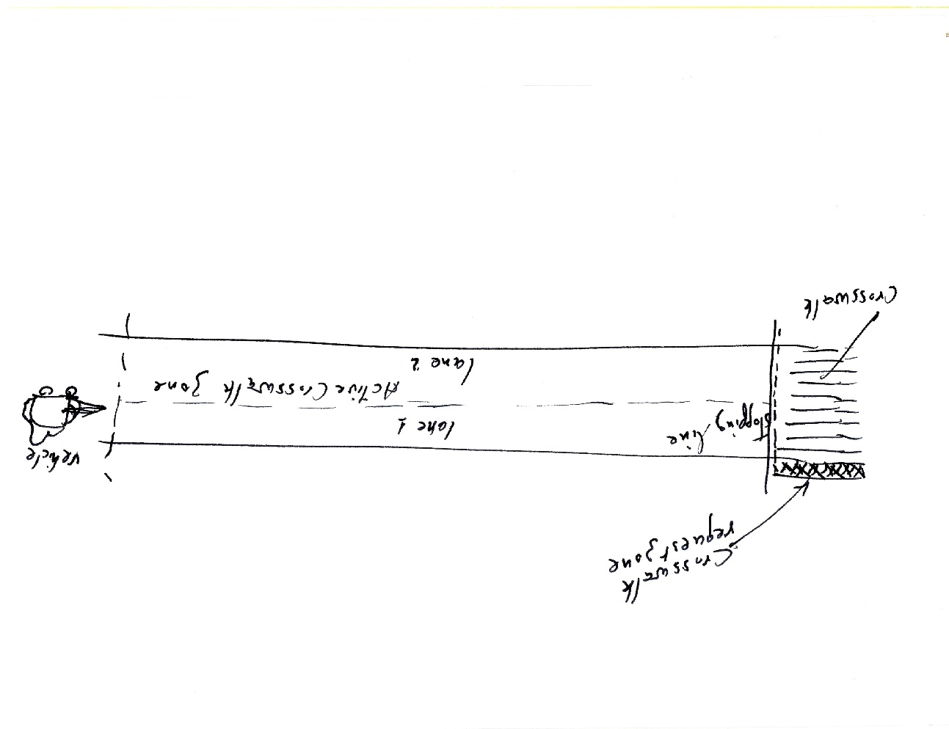

Figure 3. A sketch of the zones and active crosswalk region.

To resolve the ambiguity, abilateral interaction protocol with pedestriansand/or other approaching vehicles is initiated in the following manner:

1. Upon entering the *active crosswalk region,* the vehicle transmits a *crosswalk recognition* *signal* (e.g. through a designated display) and reduces its speed to a legally specified speed.
2. While entering the *active crosswalk region*, if a pedestrian is detected by the vehicle, either on the designated *crossing request zone* (at the entrance to the crosswalk) or on the crosswalk itself, a *stopping commitment signal* is transmitted by the vehicle to the pedestrian to indicate the commitment to stop. Concurrently, a *stopping commitment signal* is also displayed to other vehicles in the *active crosswalk region*. The vehicle reduces speed and comes to a full stop in front of the crosswalk.
3. All vehicles in the *active crosswalk region* that observe a pedestrian or a *stopping commitment signal* transmitted by another vehicle transmit a *stopping commitment signal* as well and reduce their speed to a full stop ahead of the crosswalk.
4. A pedestrian standing in the *crossing request zone* is obliged to cross, provided that: (1) no vehicle is present in the *active crosswalk region*, or (2) all vehicles in the *active crosswalk region* have either stopped in front of the crosswalk or display the stopping commitment signal.
5. Vehicles resume their motion only after *all* pedestrians have completely crossed.
6. If at the specified closer distance from the crosswalk still no pedestrian is recognized and no *stopping commitment signal* from other vehicles is observed, the vehicle may continue its motion at the specified reduced speed through the crosswalk zone at which point it may resume cruising speed.